Association of Community and Continuing Education presents the 2014 Fall Workshop:

Strengthening Our Connections
Join Us in the South
Wednesday, November 19, 2014
NOCCCD, School of Continuing Education
1830 W. Romneya Dr, Anaheim, CA 92801

Register now for this informative, one-day session in which you will get the latest information on the issues that affect our programs and share ideas for hot topics in Community and Continuing Education.

Registration Fee: $49.00
(Includes continental breakfast and lunch)
To register, send the attached form with your check (made out to ACCE), purchase order or credit card information to:
San Diego Continuing Education
ATTN: Bob Parker
4343 Ocean View Blvd., San Diego, CA 92113-1998
or FAX to (619) 388-4980

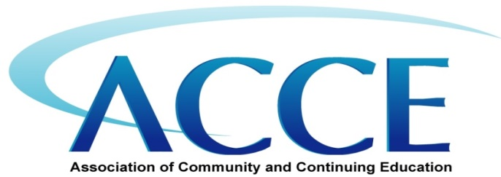

ACCE Fall 2014 SOUTHERN WORKSHOP REGISTRATION FORM
November 19, 2014

Name: |  | Title:
College:
Mailing Address:
Phone: |  | Email:
Are you (circle all that apply): continuing education, community education, workforce/economic development, other:
If you have dietary restrictions, circle vegetarian option, vegan option, gluten-free option.
Credit Card Info: | Master Card Visa American Express
Card Name: |  | Billing Address:
Card Number: |  | Security Code:
 |  | Expiration MM/YY:

Maps and driving directions will be posted on www.acceonline.org soon.
For information or questions call Bob Parker (619) 388-4894

